UDC 336.1 : 336.5 : 338.2

DIGITAL TOOLS FOR ENSURING TRANSPARENCY IN INVESTMENT ATTRACTION

Petrenko Ivan, PhD student,
pis@hnu.edu.ua
Scientific supervisor: Ivanenko Pavlo, D.Sc. in Economics, Professor, Professor of the Department of Economic Cybernetics, Khmelnytskyi National University, ivanenko@hnu.edu.ua,
ORCID: 0000-0001-0000-0000

The importance of transparency in investment attraction processes under the conditions of the full-scale war in Ukraine is substantiated [1], as openness and accountability of financial flows are key factors in strengthening the trust of donors and private investors and create prerequisites for the effective recovery of critical infrastructure.
The dynamics of investment attraction in reconstruction projects [2] can be analyzed on the basis of generalized statistical data presented in Table 1.

Table 1 – Dynamics of Investment Attraction for Infrastructure Reconstruction
Year | Investment Volume, million UAH | Growth Rate, %
2022 | 850 | –
2023 | 1240 | 45,9
2024 | 1680 | 35,5

The efficiency of the use of investment resources can be evaluated using the investment efficiency indicator, which is determined by the following formula:
, (1)
where E – investment efficiency;
I – volume of attracted investments;
C – total costs of project implementation.
At the same time, the structure of funding sources for the reconstruction of critical infrastructure is presented in Figure 1.

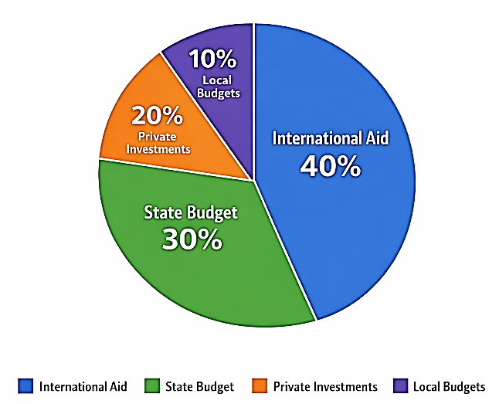
Figure 1 – Structure of funding sources for the reconstruction of critical infrastructure

References
- Popliuko A. Post-war recovery of Ukraine’s economy: experience of countries where military actions took place. Efficient Economy. 2023. No. 3. DOI: http://doi.org/10.32702/2307-2105.2023.3.28.
- Vinnichuk Y. More than $6 billion of exports per year: how Ukraine’s IT sector is growing [Electronic resource]. 2022. Available at: https://biz.censor.net/r3311585.

