On the occasion of the 60th anniversary of West Ukrainian National University
The Department of Information and Computing Systems and Control
invites students and young scientists to participate in the
The 1st International Scientific and Practical Conference of Students and Young Scientists
“ICSPM 2026: Intelligent Computing Systems and Project Management”
organized at the Faculty of Computer Information Technologies
of West Ukrainian National University

The aim of the conference is to create an international scientific communication platform for the exchange of research results, ideas, and practical developments in the fields of intelligent computing systems, software technologies, artificial intelligence, data analytics, digital technologies, and project management.
The conference will promote the scientific activity of students and young scientists by encouraging interdisciplinary collaboration, supporting the integration of young scientists into the international academic community, and creating conditions for discussing modern approaches, methods, and practices in digital transformation, innovation, cybersecurity, and automated computing technologies.
Working languages of the conference: Ukrainian, English.

Participants are invited to present papers, join the discussions, and demonstrate their own developments and innovative products.
Forms of participation: in-person and online.
For additional information, please contact the organizing committee:
Department of Information and Computing Systems and Control
Faculty of Computer Information Technologies
West Ukrainian National University
8 Olena Teliha Street, Room 6203
Ternopil, 46003, Ukraine
Tel.: +38 (0352) 51-75-24, 16-115
Website: icspm.wunu.edu.ua
Email: icspm-conf@wunu.edu.ua

Conditions of Participation
To participate in the conference, applicants must submit a completed registration form and attach the abstracts prepared according to the requirements by May 15, 2026.
https://forms.gle/uN8ysJbzH4bEmAgr9
Important: information about the acceptance of abstracts will be sent within 5 working days.
Otherwise, participants are kindly asked to resubmit the application and abstracts. Following the conference, an electronic proceedings volume will be published on the website of West Ukrainian National University and indexed in Google Scholar. Participants will also receive certificates of participation and publication.

Participation in the conference is free of charge.

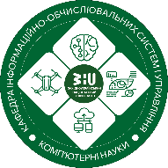



Ministry of Education and Science of Ukraine
West Ukrainian National University
Faculty of Computer Information Technologies

Department of Information and Computing Systems and Control

The 1st International Scientific and Practical Conference of Students and Young Scientists
«ICSPM 2026: Intelligent Computing Systems and Project»
May 21–22, 2026
Ternopil, Ukraine
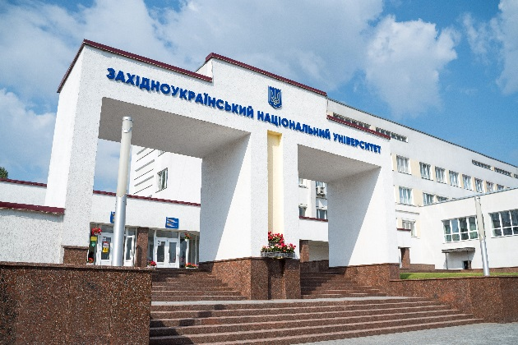
Conference Topics:
Section 1. Intelligent Computing and Software Systems
Section 2. Project-Oriented Management and Decision-Making Processes
Section 3. Artificial Intelligence, Data Analytics, and Cybernetics
Section 4. Applied Technologies and Information and Communication Systems
Section 5. Digital Transformation, Cybersecurity, and IT-Driven Innovations
Section 6. Modern Information Technologies in Economics, Law, and Education
Conference Details
The organizing committee accepts abstracts of 3–5 pages prepared in MS Word (.doc, .docx).

Formatting requirements:
- Page format: A5
- Margins: 2 cm on all sides
- Font: Times New Roman, 11 pt
- Line spacing: single
- Paragraph indent: 1 cm
Structure:
- UDC (left aligned)
- Title of the abstract (bold, centered)
- Author(s): full name (maximum 3 authors), study level (group / specialty), email (right aligned)
- Scientific supervisor (for bachelor, master, and PhD students): full name, academic degree, position, affiliation, email, ORCID
- Main text (justified)
References he list of references must follow DSTU 8302:2015 requirements.
- References should be listed in the order they appear in the text.
- Each reference must be cited in the text in square brackets (e.g., [1]).
- The list should contain 3–10 sources.
Formatting:
- Font size: 10 pt
- Alignment: justified
- Line spacing: single
- Paragraph indent: 1 cm
Figures, Tables, and Formulas
Mathematical formulas should be created using Microsoft Equation.
Figures, tables, diagrams, and schemes must be original and placed after their first mention in the text.
Image formats:
- jpeg
- jpg
- bmp
- tif
- gif
Captions:
- Font size: 10 pt
- Alignment: centered
Example:
Table 1 – Results of analysis
Figure 1 – Conceptual scheme

Academic Integrity
Authors are responsible for compliance with academic integrity principles.
- Text originality must be at least 80%.
- Self-citation must not exceed 20%.
Important: citation of sources published in russian or by russian authors, or published in the russian federation, is not allowed.
The editorial board reserves the right to edit submitted materials.
INTERNATIONAL WORKSHOP ON INTELLIGENT COMPUTING SYSTEMS AND PROJECT MANAGEMENT
(ICSPM-WS 2026)
Held within the framework of the ICSPM 2026 Conference, the workshop focuses on current research in intelligent computing systems, artificial intelligence, data analytics, and project management.
Workshop papers are accepted in English only.
Selected papers, upon peer review, will be recommended for publication in CEUR Workshop Proceedings (CEUR-WS.org).
The proceedings are expected to be indexed in:
• DBLP
• Scopus
• Web of Science
(subject to CEUR indexing).
Paper submission deadline: April 21, 2026.
Detailed information is available on the conference website: icspm.wunu.edu.ua.

